**Day – 0 :- Setup and Installations**

**Steps and Procedure:**

1. Install Python From <https://www.python.org/downloads/>
2. ****Check Python Version.

It Should be Python__ 3.2.x or newer, For Python 3.

1. ****Then Install Setup tools.
2. Now Create New Python Environment.

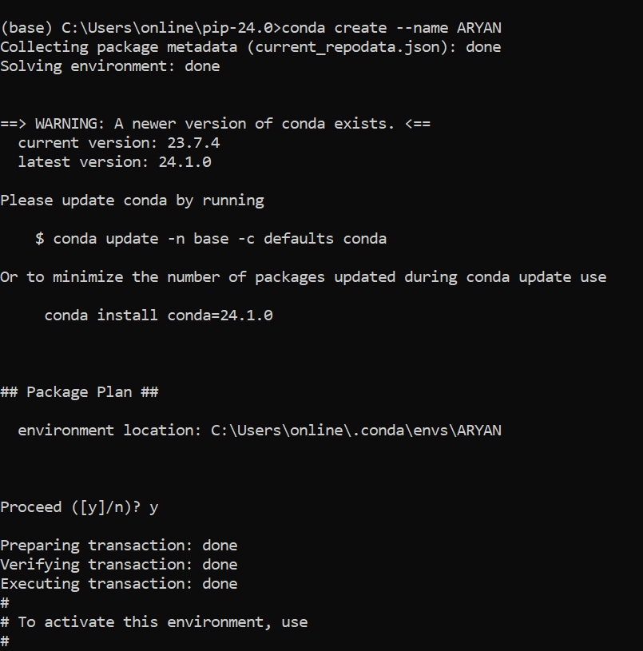

1. 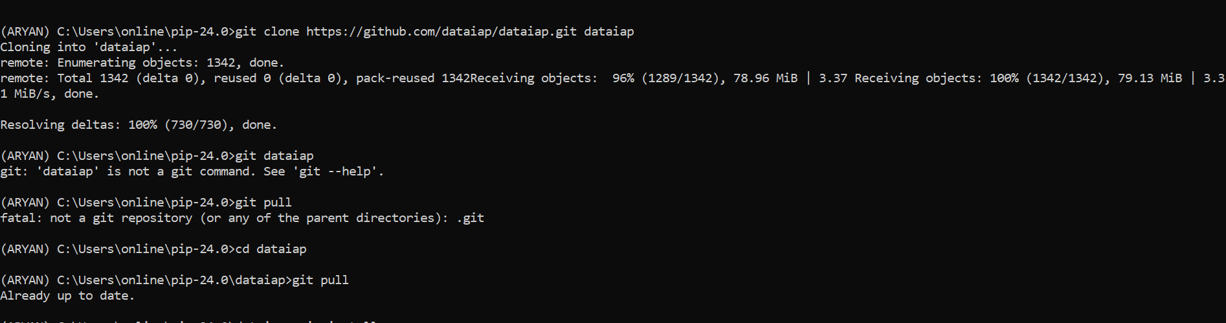Then Activate that Enviroment. Install pip-24.0.tar.gz from [https://pypi.org/project/pip/#files](https://pypi.org/project/pip/%23files) and navigate to the directory where setup.py is there and install using given commands.
2. 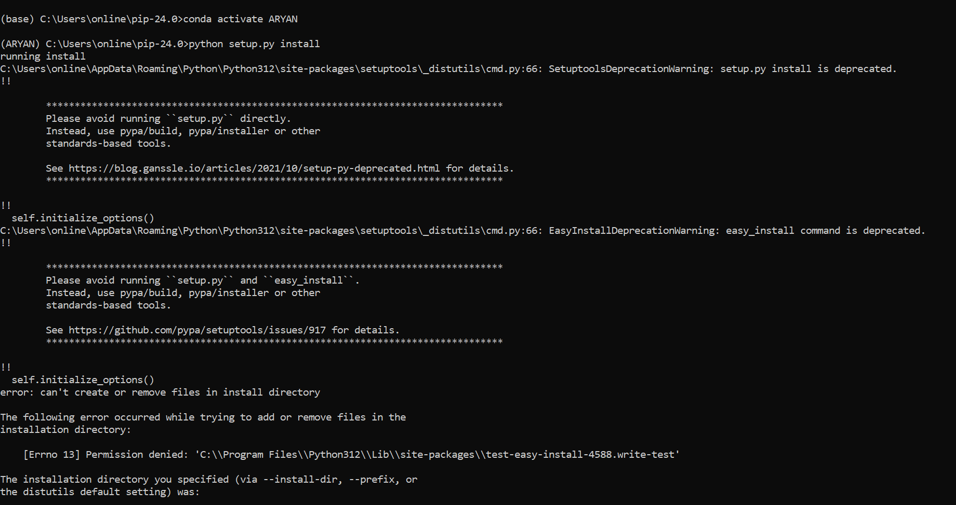 Then Clone a Git Repository and pull all the Updates

**Note :-**

Don’t Use Link **“git clone git://github.com/dataiap/dataiap.git dataiap”**

Instead Use Link **“git clone https://github.com/dataiap/dataiap.git dataiap”**

1. ****Now Install Numpy.
2. ****Now Install Scipy.
3. 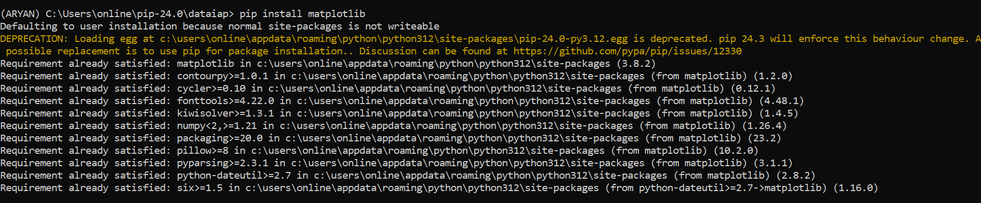Now Install Matplotlib.
4.  Now Install dateutil
5. ****Now Install pyparsing.
6. 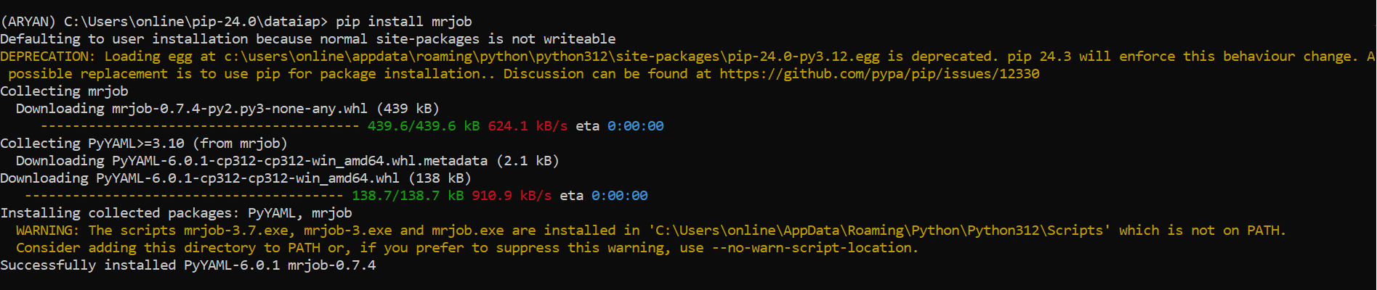Now Install mrjob.
7. 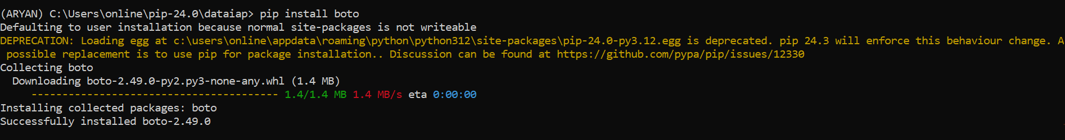 Now Install boto.
8. Now Download The Dataset

[**https://ocw.mit.edu/ans7870/RES/RES.6-009/iap12/datasets/P00000001-ALL.zip**](https://ocw.mit.edu/ans7870/RES/RES.6-009/iap12/datasets/P00000001-ALL.zip)

and unzip it at dataiap/datasets/pres_cam

**Congratulations!! You are done with all the necessary setup.**